Cultivating Our Renewed Excitement

Letter from Kim

Union County

January 2015
Volume 9, Issue 4

Beta Pi Newsletter

Important Dates
Jan. 12th meeting at The Hen House
Dinner & Meeting
February 3-4, 2015 - Legislative Symposium
March 20-21 - Advanced Leadership Management Seminar
June 4-6, 2015 - Xi State Convention at Sewanee
July 14-18, 2015- Southeast Regional at Westin Hotel in Savannah, Georgia

Visit Beta Pi: www.xibetapi.weebly.com
Xi State: www.xistate.org
And ΔΚΓ: www.deltakappagamma.net

The Delta Kappa Gamma Society International promotes key women educators.

Xi State - Tennessee

Hello Beta Pi Sisters,
Brrr.......Happy New Year!!! Welcome 2015. I hope everyone had a terrific holiday and a well deserved break. I also hope everyone has escaped the flu. I have managed to escape it so far. I know of several people that have had it, and it sounds horrible, but let's not talk about it! Just be thankful if you have escaped it. Has anyone made any New Years Resolutions? As usual, I always resolve to eat healthier and exercise, that only lasts a little while. I am determined to try harder this year. If anyone cares to share their resolutions, email them out to all of us and maybe we can help encourage each other on keeping them.
We have a sister that is in need of our prayers, and that is Rosemary Smith. She is a member of the Iota chapter, and she has a tumor on her brain. She is in great need of our thoughts and prayers.
We had a great time at our Beta Pi Christmas Party. We met at Club Le Conte and had a fantastic dinner. We also played "Dirty Santa" with Christmas ornaments and "Thank the Lord,” it didn't get, too dirty, this year!!! We also had door prizes for the attendees. We had more attend this year than ever before. We missed those of you that did not get to attend. Maybe next year.
Everyone please make it a point to attend our next meeting. It is coming up very soon.
Thank you for all that you do for Beta Pi,



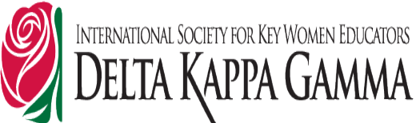

& Move
-Kim
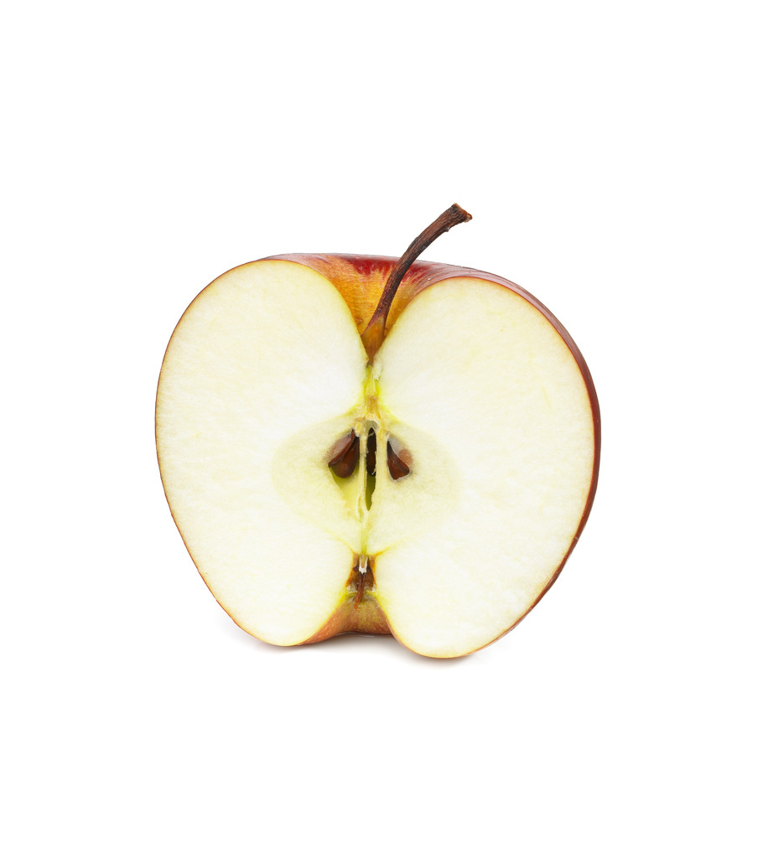

September Meeting

January Meeting

Make plans now to attend our January meeting. This month, we will meet at The Hen House on Emory Rd. at 4:30 p.m. Bridget Calfee’s mother-in-law has opened this space as a “hang out” for women. She is very supportive of teachers, as she is one herself. We will have dinner at 5:00 p.m. Cost is $10.
Menu: Loaded Potato Soup
Sandwiches: Ham or Pimento-Cheese (w/chips & pickle)
Cookies
Tea (sweet & unsweet) w/ flavoring
Directions: From Harbison’s Crossroads – Turn toward Corryton (between Wiegel’s and the bank), Go past the big curve where the church and gas station are located, it is on the left before Roberts Rd.)
Hostesses
Lana Booker & Rachel Hodges

Beta Pi Newsletter Page 2

Attendance Drawing
Don’t forget we will have an attendance drawing in May. Each time you attend a meeting, you get your name put in the box. The prize this year will be a bracelet. More details to come!

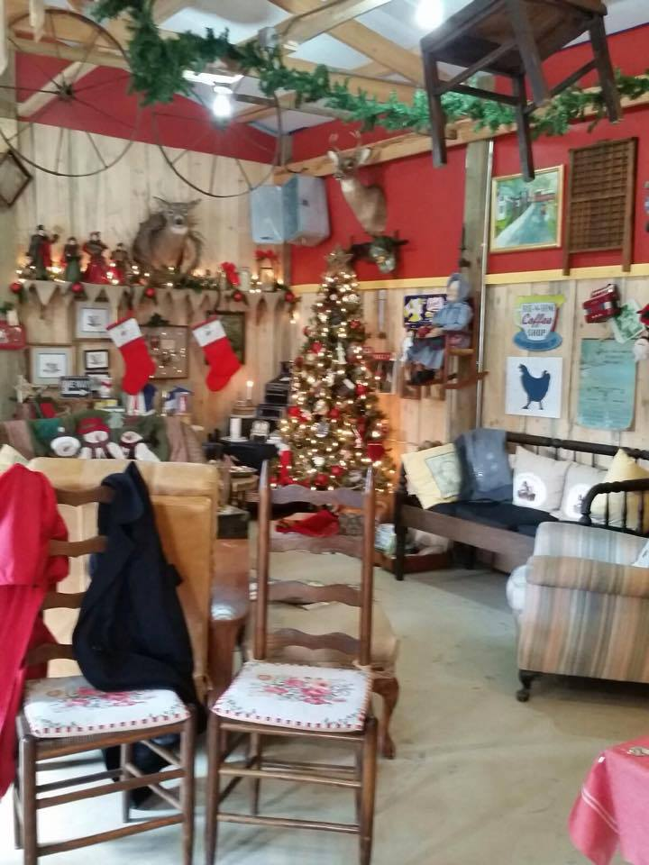
The
Hen
House

2014 Christmas Party

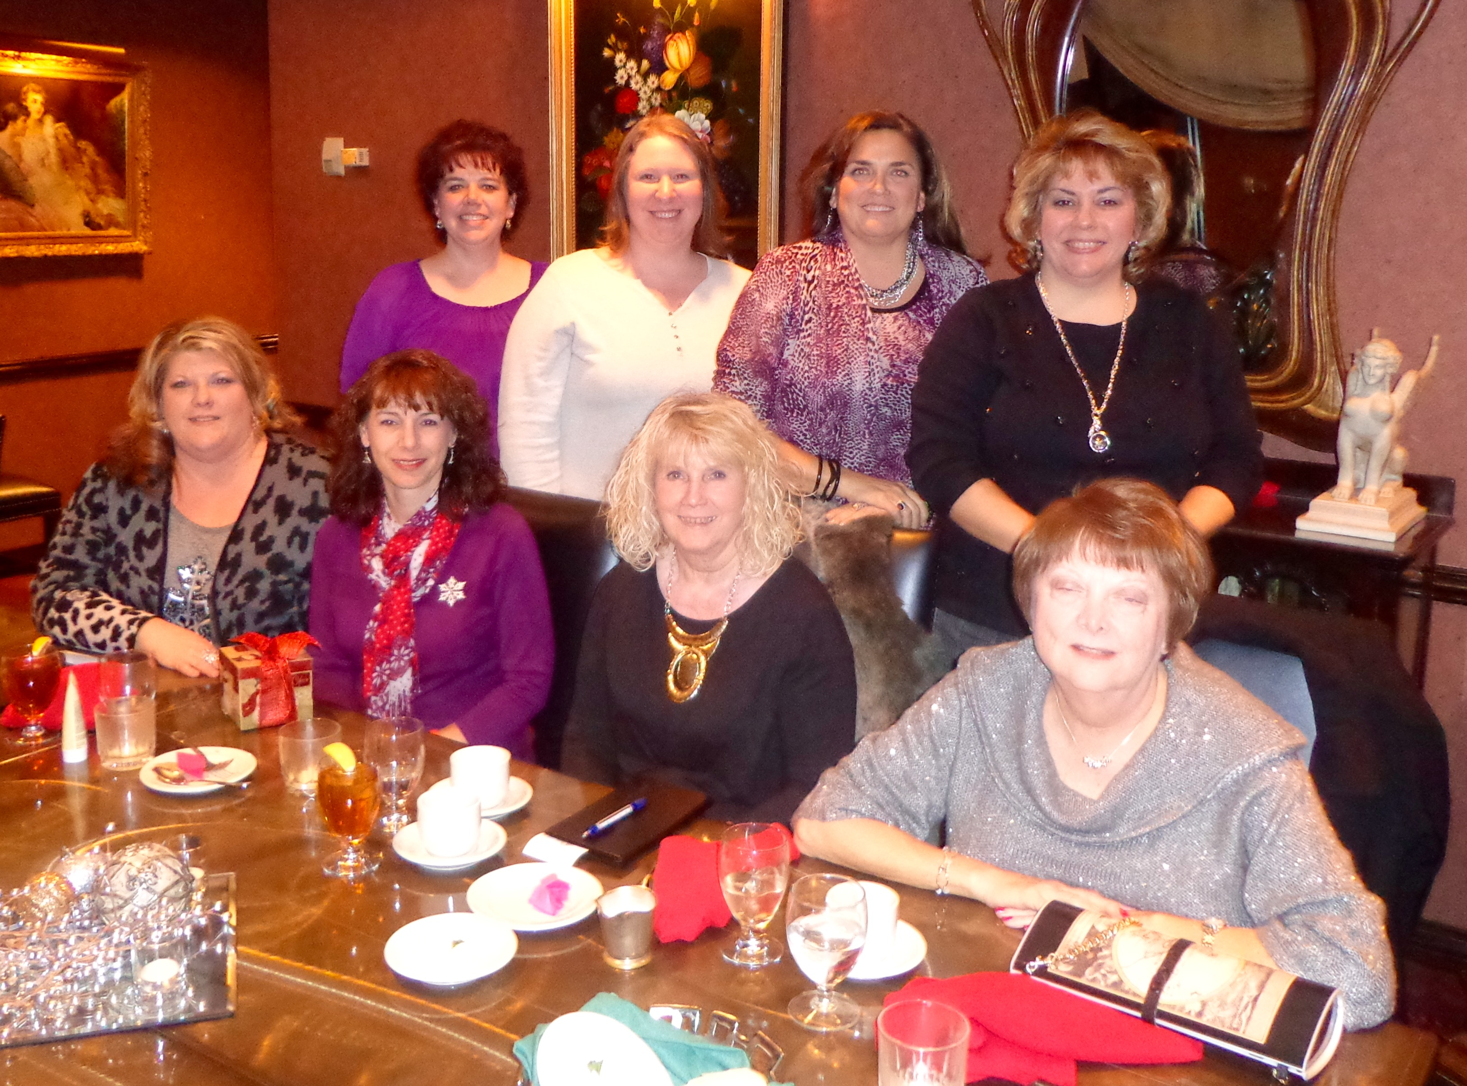

Education News

Congress extends educator tax deduction—for now
The Senate passed the House-approved bill that extends more than 50 tax breaks, including the $250 tax deduction for educators who purchase classroom supplies and instructional materials. The good news is that educators who made such purchases in 2014 will be able to take the deduction. The bad news is the measure expires on December 31, and Congress will have to debate the issue again to renew the deduction for 2015 and beyond.

We had another wonderful time at our Christmas Party at Club le Conte this year! Beta Pi members gathered high atop Knoxville on the last day of school to celebrate another year of sisterhood and friendship. The food was wonderful, of course, and we really enjoyed the egg-nog! Our ornament exchange was once again a hit. There were so many beautiful items that we all just kept the ones we opened! This was a delightful way to end the year, and begin the holiday season. Here’s to looking forward to a new year in DKG.
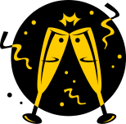



Birthdays:

Beta Pi Website

Don’t forget to visit our website at www.xibetapi.weebly.com. If you have suggestions or corrections, please send
to: collins.sherrie@gmail.com.
*Our website has received the official sticker from International for the biennium.
Susan Oaks – Feb. 4


